**Project Design Phase-II**

**Data Flow Diagram & User Stories**

|  |  |
| --- | --- |
| Date | 19 Oct 2023 |
| Project Name | Food Tracking System |

**Data Flow Diagrams:**

A Data Flow Diagram (DFD) is a traditional visual representation of the information flows within a system. A neat and clear DFD can depict the right amount of the system requirement graphically. It shows how data enters and leaves the system, what changes the information, and where data is stored.

**Example:**

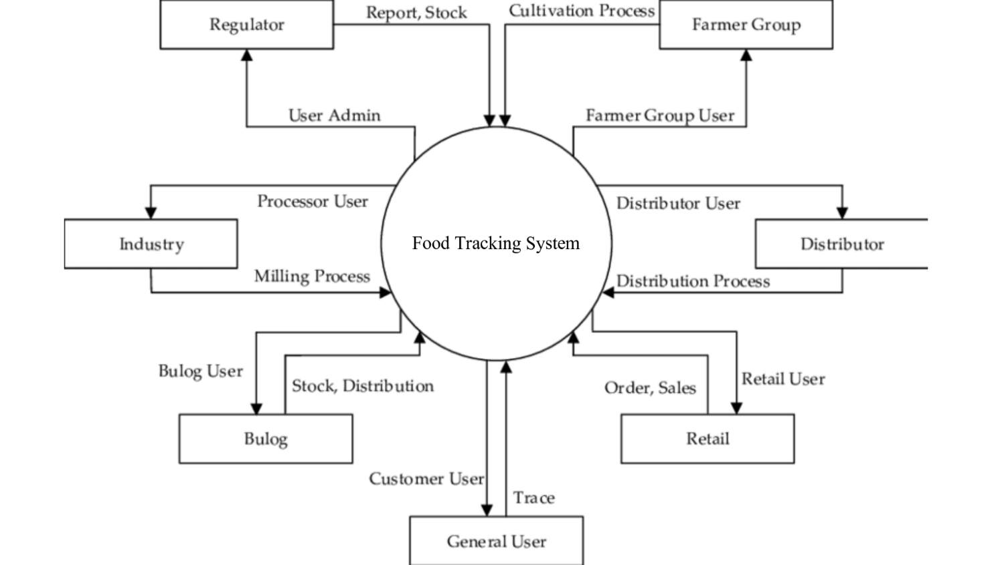

**User Stories**

Use the below template to list all the user stories for the product.

| **User Type** | **Functional Requirement (Epic)** | **User Story Number** | **User Story / Task** | **Acceptance criteria** | **Priority** | **Team Member** |
| --- | --- | --- | --- | --- | --- | --- |
| Consumer | Product Verification | USN-1 | As a consumer, they want to verify the authenticity and origin of food products before making a purchase. | I The system displays detailed product information, including origin, production date, and certification.I can scan a QR code or enter a product code to access product details. | High | A.R,Mohammad Javid |
| Farmer | Production Data Input | USN-2 | As a farmer/producer, they want to input data about the production process into the system. | I can create a new record for each batch of produce.I should input data such as planting date, harvesting date, and quality control results. | High | R.M.R.Rajamani |
| Distributor | Supply Chain Management | USN-3 | As a distributor/supplier, they want to manage the transportation and distribution of food products efficiently. | I can update the system with shipment and delivery information.I should verify the quality and safety of the products during the transfer. | High | M.Praveen Kumar |
| Retailer | Inventory Management | USN-4 | As a regulatory authority, they want to ensure that the system complies with food safety regulations and standards. | The system provides real-time updates on product availability and expiration dates.I can use the system to track sales and restock products as needed. | Medium | S.Sangilimuthu |
| Regulatory Authority | Regulatory Compliance | USN-5 | As a regulatory authority, they want to ensure that the system complies with food safety regulations and standards. | I can access the system for audits and inspections. | High | - |